Title, One page abstract shown here

*Gildong Hong1) and Jeonghan Lee2)

^{1), 2} Shila Strcutral Engineering Co., Ltd., Seoul 05006, South Korea
¹⁾ gildong.hong@ksas.or.kr

ABSTRACT (pls, use 70~100 words)

One page abstract shown here. Enhanced three-dimensional finite elements for geometrically nonlinear analysis of cable supported structures are presented. The cable element, derived by using the concept of an equivalent modulus of elasticity and assuming the deflection curve of a cable as catenary function, is proposed to model the cables. The stability functions for a frame member are modified to obtain a numerically stable solution. Various numerical examples are solved to illustrate the ……

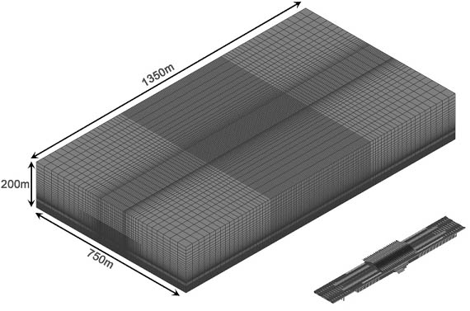

Fig. 1 Computational meshes for Gyeongju station (Optional)

REFERENCES (Optional)

Cadappa, D.C., Sanjayan, J.G. and Setunge, S. (2001), “Complete triaxial stress-strain curves of high-strength concrete”, J. Mat. Civil Eng., ASCE, 13(3), 209-215.
Chern, J.C., Yang, H.J. and Chen, H.W. (1992), “Behavior of steel fiber reinforced concrete in multiaxial loading”, ACI Mat. J., 89(1), 32-40.

1) Chairman
2) Project Manager

